BERNARD OWUSU SEFAH

LATCHES AND FLIP-FLOP

Task 1

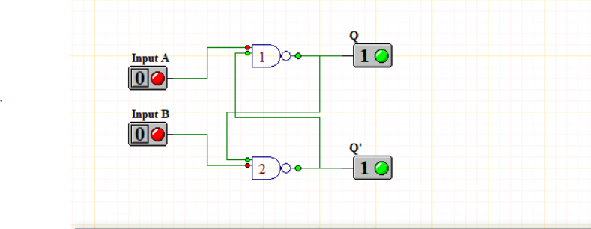

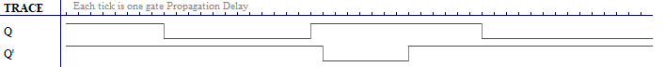

Task 2

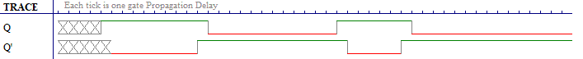

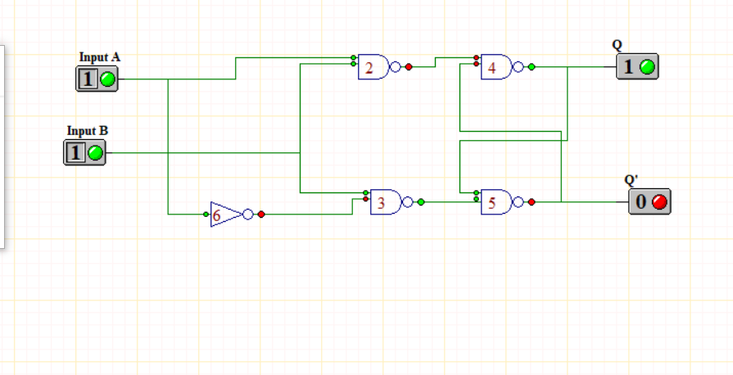

Task 3

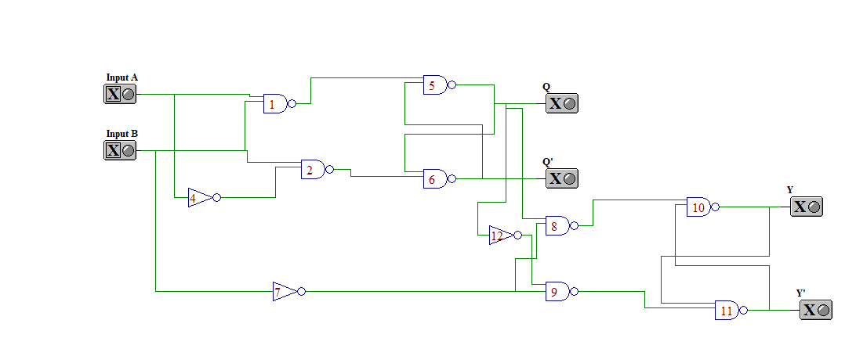

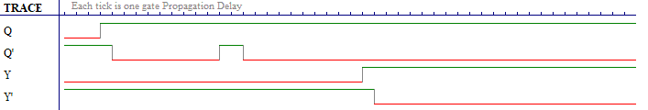

Task 4

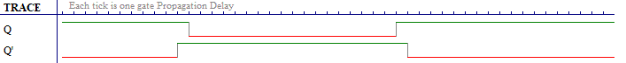

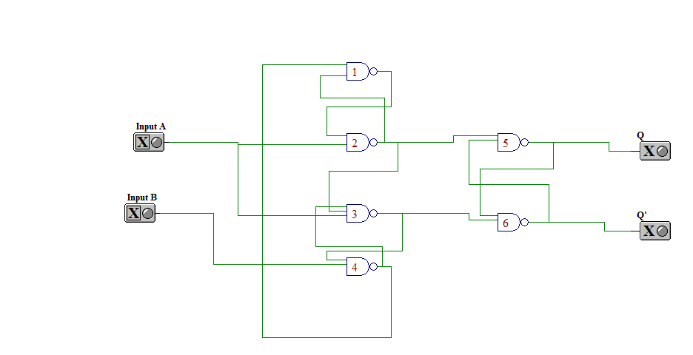

Task 6

SR Latch

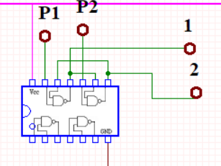

D-Latch

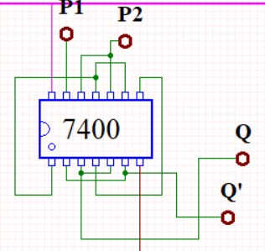

Master Slave D FF

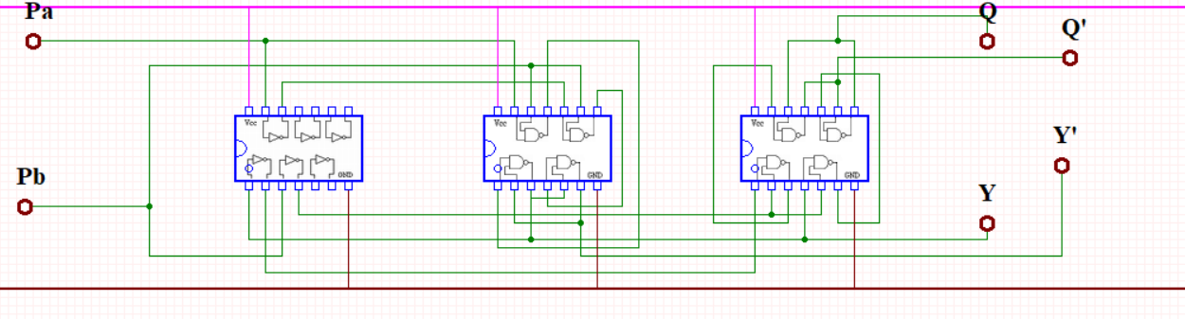

D-Type Positive-Edge Triggered FF

